**ATAR HUMAN BIOLOGY – UNIT 1**

**TASK 3 – METABOLISM, CIRCULATORY AND RESPIRATORY SYSTEMS TEST**

**NAME: _________________________________ WEIGHTING: 5%**

**DUE DATE: _________________________________ MARK: ______ /57 = ______ %**

Important Information for Students

1. There are THREE sections in this test - Multiple Choice, Short Answer and Extended Answer.
2. This is a closed-book assessment (no notes are allowed)
3. The time allowed to complete the test is 60 minutes.
4. Write your answers to the Multiple Choice section on the **separate** answer sheet provided. Circle only 1 answer.
5. Write your answers to the Short Answer section in space provided.
6. Write your answers to the Extended Answer section in space provided

|  |  |  |
| --- | --- | --- |
| Sections | **Marks Allocation** | **Your Total** |
| **A - Multiple Choice** | 9 |  |
| **B - Short Answer** | 38 |  |
| **C - Extended Answer** | 10 |  |
| **TOTAL** | **57** |  |

**Multiple Choice Answer Sheet**

Answer all questions by placing a circle around the correct letter.

1. A B C D

2. A B C D

3. A B C D

4. A B C D

5. A B C D

6. A B C D

7. A B C D

8. A B C D

9. A B C D

**MULTIPLE CHOICESECTION [9 MARKS]**

1. The trachea contains cells that have cilia. What is the function of the cilia?
   1. To give shape to the trachea
   2. To help move the gases to and from the lungs
   3. To move mucus and trapped particles out
   4. To increase the surface area of the trachea
2. As blood enters the capillaries, the relatively high pressure forces some of the fluid in the blood in through the capillary walls into the tissues. How is this fluid returned to the heart?
   1. The effect of gravity on the body returns the fluid to the heart
   2. Osmosis returns the fluid to the heart
   3. Combination of contracting muscles and valved vessels of the lymphatic system
   4. Fibrin and serum capture the fluid and return it to the heart
3. If a person has a heart rate of 70 beats per minute and a cardiac output of 1400ml per minute then their stroke volume would be:
4. 20mls
5. 200mls
6. 100mls
7. 70mls
8. Which of the following is true of gaseous exchange through the walls of the alveoli?
9. Net diffusion of oxygen is from the alveoli to the blood capillaries.
10. Diffusion of carbon dioxide occurs at the same rate in both directions.
11. Net diffusion of carbon dioxide is from the alveoli to the blood capillaries.
12. Diffusion of oxygen occurs at the same rate in both directions.
13. The process in which a substance spreads from an area of high concentration to an area of low concentration is:  
    1. exocytosis
    2. facilitated diffusion
    3. active transport
    4. pinocytosis
14. Alien Hand Syndrome is neurological disorder caused by a stroke and damage to the parietal lobe. The brain tissue is deprived of oxygen. Select what will happen to Adenosine Triphosphate (ATP) formation after oxygen has been deprived.  
    1. Metabolism increases as the cells try to gain more oxygen and nutrients for ATP formation.
    2. Anaerobic respiration is used for ATP formation.
    3. Aerobic respiration occurs to increase oxygen to the brain cells for ATP formation.
    4. Enzymes are released to move nutrients to the cells for ATP formation.
15. 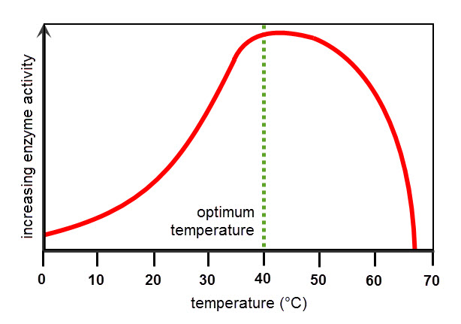Hyperthermia is a condition where the core temperature of the body increases so high that a person suffers from a fever or even death. The graph below shows the relationship between core body temperature and enzyme action.

What is happening to the enzyme action of a person suffering hyperthermia and why?

* 1. Increases – due to decrease in activation energy.
  2. Increases – due to increased concentration of enzymes.
  3. Decreases – due to decreased cell permeability.
  4. Decreases – due to enzymes denaturing.

1. In which of the following would you expect blood pressure to be at its highest?
2. The pulmonary artery
3. The aortic arch
4. The inferior vena cava
5. A capillary in your finger
6. Which of the following is not a function of the nasal cavity?
7. Warm and filter air
8. Act as a resonating chamber for sound
9. Provide a surface to detect odours
10. Channel air into the trachea and not the oesophagus

**SHORT ANSWER SECTION [38 MARKS]**

This section has **nine** questions. Answer all questions in the spaces provided.

**Question 1** **[13 marks]**

Below is a cross-sectional diagram of a human heart

II

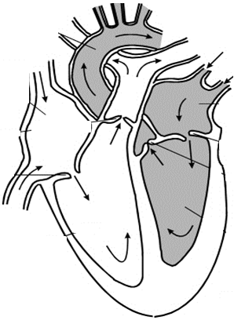

V

III

I

IV

1. Label the following structures: *[2 marks]*

II Aorta

V Pulmonary vein

1. Explain what would happen to structures I and IV during diastole and atricular systole.

*[2 marks]*

Diastole – IV closed, I open (1 marks for both)

Atricular Systole – IV closed, I open (1 mark for both)

1. Your heart is made of muscular tissue. State two types of tissue found in your finger *[1 mark]*

Nervous, epithelial and connective (any two)

1. Sometimes babies can be born with a hole connecting the two atria of the heart. Using your knowledge of the circulatory system, explain why a ‘hole in the heart’ is a serious problem.  *[2 marks]*

*Allow deoxygenated and oxygenated blood to mix/reduce amount of oxygen in blood leaving heart for body or in aorta(1)*

*Reduces pressure as chambers cannot fill properly (1)*

1. State and explain two ways that red blood cells are perfectly structured for their function of carrying oxygen. *[4 marks]*

Biconcaved disc (1) – gives a greater surface area for diffusion (1)

Contains haemoglobin (1) – gives better ability to carry gases (1)

Has no nucleus (1) – more room for carrying gases (1) Any two structure and function

1. Bicarbonate ions are the product of a chemical reaction within the body. Explain how these ions are formed.  *[2 marks]*

Carbon dioxide reacts with water in blood to make carbonic acid (1)

Carbonic acid separates to form hydrogen ions and bicarbonate ions (1)

**Question 2 [9 marks]**

* 1. With reference to the lymphatic system, explain why exercising can reduce the chances of you getting a bacterial infection. *[3 marks]*

Lymph is moved in the lymphatic system by the movement of your voluntary muscles (1)

White blood cells which kill bacteria found in the lymph nodes (1)

As you exercise lymph pushed through the nodes quicker so bacteria found and destroyed (1)

* 1. When any blood vessel is damaged, blood escapes and after a few minutes the blood flow stops as it thickens and forms a clot. Outline **four (4)** events occurring in the blood vessel and blood which stop the bled.  *[4 marks]*

Platelets stick to the open wound (1)

Clotting factors produce fibrin (1)

Fibrin forms a mesh over the platelets (1)

Clot retraction occurs pulling the “material” together/mesh tighter (1)

* 1. A person is involved in a crash accident, out on the Eyre Highway. Because he is losing blood fast the paramedics decide to he needs to be given blood to replace what he has lost. Unfortunately, the person is unable to talk and cannot tell paramedics what blood group he has. What blood could he be given and describe why.  *[2 marks]*

Blood group O (1), has no antigens on surface so is not recognised as foreign (a reasons to why no antibodies would be made against it) (1)

**Question 3 [7 marks]**

1. 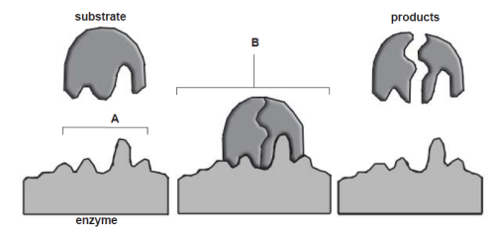The following question refers to the diagram below, which shows the events that occur during a reaction involving an enzyme.
2. State whether the reaction shown in the diagram is a catabolic or anabolic reaction, and explain how you know.  *[2 marks]*

Catabolic (1),

reason (1) eg substrate is turned into two or more products

1. 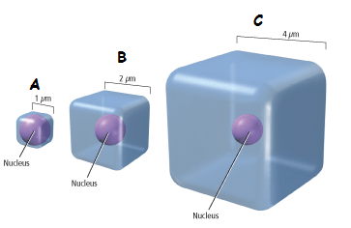The following question refers to the diagram below.
2. Which of the cells in the diagram above (A, B or C) would supply its organelles with the substances they require most efficiently? Explain your reasoning.  *[2 marks]*

*A(1) –*

*reason (1)- has a large surface area to volume ratio needed for efficient diffusion*

1. The table below shows the change in mass of the eggs overnight in the three different solutions. Use the information to answer the following question.

|  |  |  |  |
| --- | --- | --- | --- |
| Egg | Start mass (g) | Final mass (g) | Difference (g) |
| 1 | 59.9 | 53.2 | - 6.7 |
| 2 | 58.4 | 63.6 | 5.2 |
| 3 | 57.4 | 57.5 | 0.1 |

One of the eggs was placed in concentrated sugar syrup. From the data provided, identify which egg this was and explain why its weigh changed. *[3 marks]*

*Egg 1 (1),*

*water concentration higher inside than out(1 – difference between inside and out)*

*Water moves out by diffusion reducing the weight of the egg (1)*

**Question 4 [9 marks]**

Below is a diagram of the internal structure of the lungs.

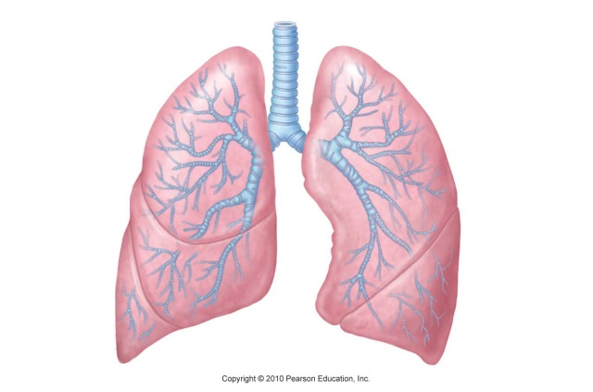

1. The lung is a very good example of a surface which enables exchange of materials to occur efficiently in the human body. Describe two features of the lungs that make them well-suited to gas exchange. *[2 marks]*

|  |  |
| --- | --- |
| **Feature (any 2)** | **Reasoning (with correct reasoning)** |
| Alveoli Large SA:Vol | Increase rate of diffusion |
| Bronchi Tree Large SA:Vol | Creates large surface area for gas exchange |
| Alveoli moist | Allow for gases to diffuse in and out |
| Alveoli one cell thick | Short distance for gas exchange |
| Good blood supply | Maintain concentration gradient/delivery or removal of gases |
| Rings of cartilage | Keeps airways open to allow gases to move in and out |
| Cillia | Keep debris from clogging up the alveoli to maximise gas exchange |

1. The trachea and bronchi have C-shaped cartilage surrounding them. What is the purpose of the cartilage?  *[1 mark]*

To keep the airways open

1. Identify the main structures that have a role in the movement of air into the lungs. Describe the role played by each structure. *[6 marks]*

1 mark for feature, 1 mark for its role x 3

|  |  |
| --- | --- |
| **Feature (any 2)** | **Reasoning (with correct reasoning)** |
| diaphragm | Contracts/ relaxes changing volume in lungs |
| Intercostal muscles | Contracts/ relaxes changing volume in lungs |
| Pleural membrane/fluid | Sticks lungs to rib cage so can change volume |
| trachea | Allows air to be drawn in/pushed out from lungs |
| Nasal passage | Warms and cleans air before entering |
| Anything suitable | Suitable connnection |
|  |  |

**EXTENDED ANSWER SECTION [10 MARKS]**

Laura is an avid cyclist. Each morning she wakes up early and goes for a 1 hour cycle. Her leg muscles have become very efficient at using oxygen to make the energy she needs to continue cycling.

Explain, in detail, the process that the mitochondria in her leg muscles are going through to produce these large quantities of energy. In your answer, include a description of how the oxygen needed for this process moves from the outside world to the mitochondria in her legs.

Aerobic respiration (1)

Glycolysis in cytoplasm (1) produces pyruvate and 2 ATP (1) do we need this?

Krebs cycle/citric acid cycle in mitochondria (1) breaks down the pyruvate more producing 2 ATP (1)

Electron Transfer Chain in mitochondria (1) furthers breakdown using oxygen and produces carbon dioxide and water plus 34 ATP (1)

Inhalation/inspiration draws air into the lungs (1)

Oxygen passes from the alveoli into the capillaries surrounding alveoli by diffusion (1)

Most Oxygen carried in RBC making oxyhaemoglobin (1)

Small amount carried dissolved in the blood (1)

Blood goes into pulmonary veins to the heart (1)

Heart pumps the blood out into the aorta to her legs (1)

Oxygen will diffuse from the capillaries surrounding her leg muscles into the cells of her muscles (1)